CSA1715 – ARTIFICIAL INTELLIGENCE
P.SAI SWETHA
192324011
DATE: 14-07-2026

LAB EXPERIMENTS:

EX – 2 :

8-Queen Problem
Aim
To solve the 8-Queen problem using the Backtracking Algorithm in Python.
Algorithm
- Place the first queen in the first row.
- Check whether placing the queen is safe.
- If safe, move to the next row.
- If not safe, try the next column.
- If no column is safe, backtrack.
- Continue until all 8 queens are placed.
- Print the board.

Code:

N = 8

board = [[0]*N for _ in range(N)]

def is_safe(board, row, col):
for i in range(col):
if board[row][i]:
return False

i, j = row, col
while i >= 0 and j >= 0:
if board[i][j]:
return False
i -= 1
j -= 1

i, j = row, col
while i < N and j >= 0:
if board[i][j]:
return False
i += 1
j -= 1

return True

def solve(board, col):
if col >= N:
return True

for i in range(N):
if is_safe(board, i, col):
board[i][col] = 1

if solve(board, col + 1):
return True

board[i][col] = 0

return False

if solve(board, 0):
for row in board:
print(row)
else:
print("No Solution")

output:
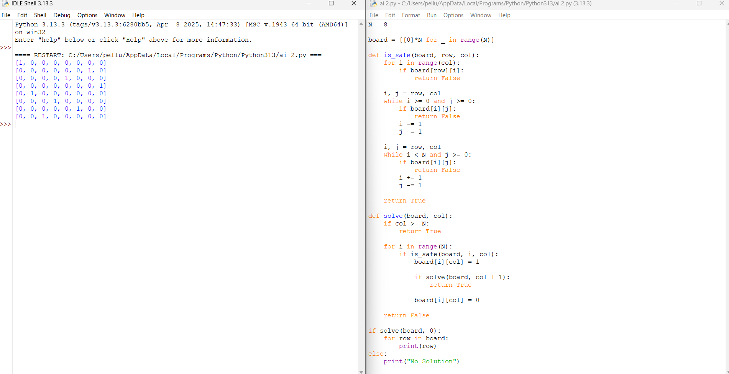
Result :
The 8-Queen problem was successfully solved using the Backtracking algorithm. The program placed all eight queens on the chessboard such that no two queens attacked each other, and a valid solution was displayed.

